**Django Application**

Let’s make a quick recap of what happens when the user sends a request to fetch the data. This request will go to the web application. Since we are using Django, the request will go to the Django framework. Whenever we build a project using the Django framework we get a specific file called URLs. In the urls.py file, we do the mapping right from where to get the request and where to send the request, and this navigation will go to views. You may get a doubt, What are views ?. So the business logic that we want to write is done in views and then these views use the model object to fetch the data and the fetched data is displayed by the template.

You will get more clarity by looking at the following MVT diagram.

**Model View Template**

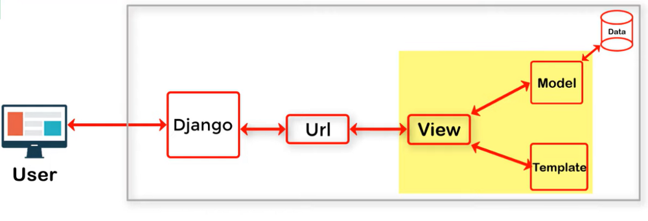

Let’s make a web application using Django for the sum of two numbers, where we create a home page consisting of a form with two input fields and a submit button and we display the addition of two numbers in the result page.

To create our project run the command:

django-admin startproject django_application

After Creating the project move into the project directory and run the server by using the following command, and You will find a successful message

python manage.py runserver

To create our application run the command:

python manage.py startapp addition

After creating the application we need to Configure our application by adding it to the INSTALLED_APPS list in the settings.py file.

INSTALLED_APPS = ['addition.apps.AdditionConfig', 'django.contrib.admin','django.contrib.auth','django.contrib.contenttypes','django.contrib.sessions',django.contrib.messages','django.contrib.staticfiles',]

Then create a templates folder in the project directory with two Html files

1. home.html (for displaying the form)

2. result.html (for displaying the addition of two numbers)

Then add the path of the templates folder to the TEMPLATES list in the settings.py file as follows

TEMPLATES = [{

'BACKEND': 'django.template.backends.django.DjangoTemplates',

'DIRS': [**os.path.join(BASE_DIR,'templates')**],

'APP_DIRS': True,

'OPTIONS': {

'context_processors': [

'django.template.context_processors.debug',

'django.template.context_processors.request',

'django.contrib.auth.context_processors.auth',

'django.contrib.messages.context_processors.messages',],},},

]

Create a form in home.html as follows

<div class="form-action" style="width:300px">

<form action="result" method="POST" >

{% csrf_token %}

<label for="num1">Enter the Number 1 </label>

<input type="text" class="form-control" name='num1'>

<br>

<label for="num2">Enter the Number 2</label>

<input type="text" class="form-control" name='num2'>

<br>

<input type="submit" value="Add">

</form>

</div>

**Note: Whenever we create a form in Django we need to use the csrf token inside it and the method must be POST.**

To the result.html file add the following jinja code.

Result={{result}}

Create a urls.py file in addition directory and add the path of views to it as follows

from . import views

from django.urls import path

from django.urls.conf import include

urlpatterns = [

path('',views.home,name='home'),

path('result/',views.result,name='result'),

]

Now Let’s Create views for both template files in the views.py file of the addition folder as follows

def result(request):

num1=int(request.POST['num1']);

num2=int(request.POST['num2']);

return render(request,'result.html',{'result':num1+num2});

def home(request):

return render(request,'home.html');

As we have seen earlier in Model View Template Design, After URL mapping request is sent to views and now these views are used to render the template files.

we need to add our application URLs path to the URL patterns list in the project urls.py file as follows. Since we need our application as the home page of our project we use empty codes.

from django.contrib import admin

from django.urls import path

from django.urls.conf import include

urlpatterns = [

path('admin/', admin.site.urls),

path('',include('addition.urls')),

]

Finally, we have done with the application

Home Page

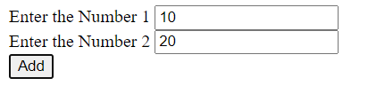

Result Page